Double click on the blue CAMA Files link. This will download the CAMA data as a compressed file (.zip). The file will download as CAMA_Files.zip. Once downloaded, right click on the zip file and tell it to “Extract All’. In the dialogue box “Browse” to the folder the files will be going to and click “Extract”
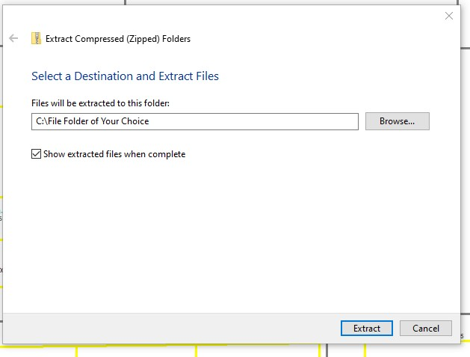
When downloaded and extracted (uncompressed) they will appear like this.

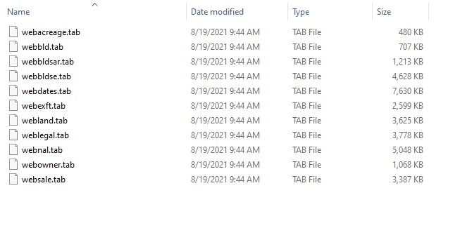
Open Excel and navigate to the file location. You may have to select “All Files” in the Open dialogue box to see the files you need.
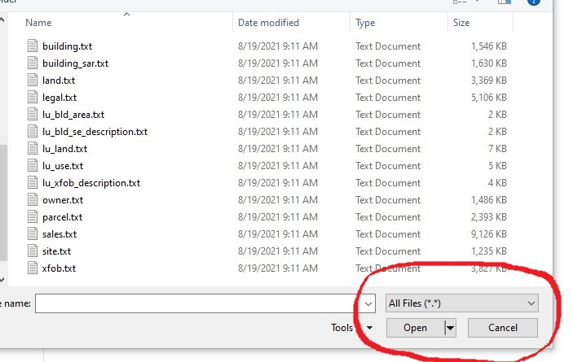
Click on the file you want to open. This will appear.
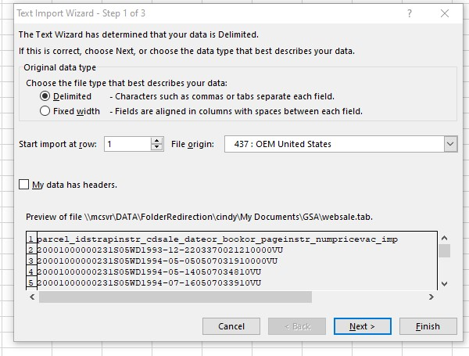
Click “Next” (This is a Tab Delimited file.)
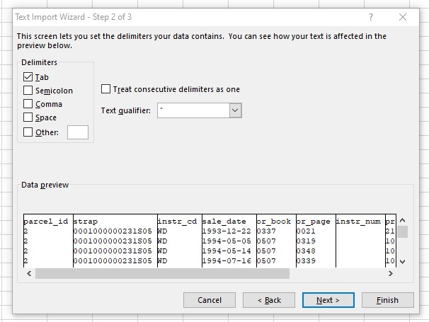
Click “Next”
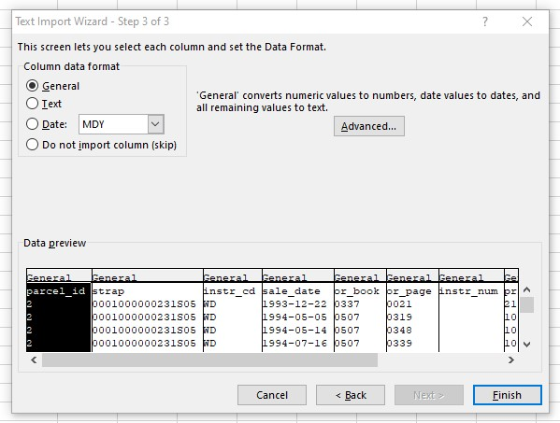
If you know how you can highlight each field and format it to “Text”, “Date” “Currency” etc, however it is not necessary.
Click “Finish”
”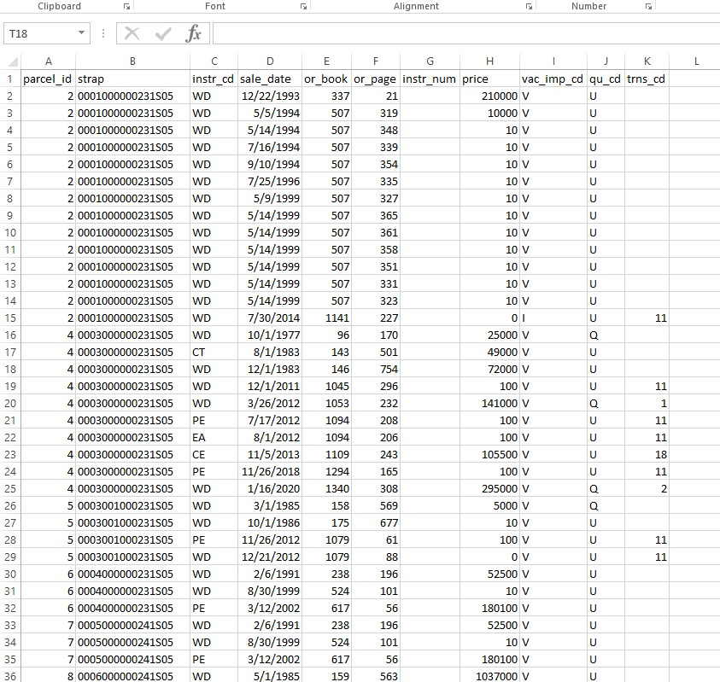
This is an example of what the data will look like. You may need to format the column width. The first row is the column headers.
You can save this file as a “Tab Delimited” or chose “Save As” and save it as the Excel file of your choice.

